SQL Count() Function
Last Updated : 22 Nov, 2025

The SQL COUNT() function is used to return the number of rows or non-null values in a column. It helps summarize data in reports and analytics.
- Counts all rows or rows with a condition
- Counts unique values using COUNT(DISTINCT column)
- Commonly used with GROUP BY and HAVING for grouped results
Example: First, we create a demo SQL database and table, on which we will use the COUNT() functions.
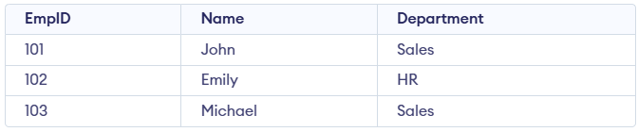Employee Table
Query:
SELECT COUNT(*) AS TotalEmployees FROM Employee;
SELECT COUNT(DISTINCT Department) AS UniqueDepartments
FROM Employee;
Output:
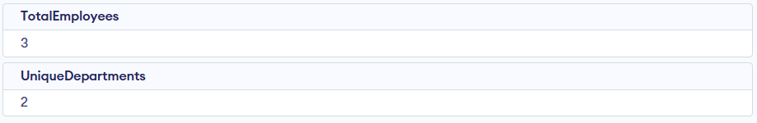
- First query returns total number of employees.
- Second query returns count of unique departments.
Syntax:
COUNT(expression)
1. Count all rows:
SELECT COUNT(*) FROM table_name;
2. Count distinct values in a column:
SELECT COUNT(DISTINCT column_name) FROM table_name;

Examples of SQL Count Function
Let’s explore practical examples of the COUNT() function using a sample Customers table; consider the table below for all examples.
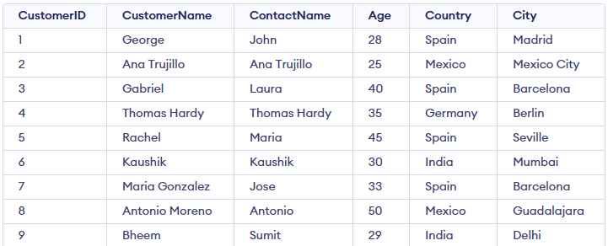Customers Table

1. Counting the Number of Rows with COUNT(*)
When we want to count all the rows in a table, regardless of the column values, we can use COUNT(*). It counts every row, including rows with NULL values.
Query:
SELECT COUNT(*) AS TotalCustomers
FROM Customers;
Output:
- This query counts all the rows in the Customers table, including those with NULL values in any column.
- The result 9 indicates that there are 9 rows in the Customers table.

2. Counting Unique Values with COUNT(DISTINCT …)
Sometimes, we may need to count only the distinct values in a column. The COUNT(DISTINCT column_name) function allows us to count only unique entries in a column, ignoring duplicates.

Query:
SELECT COUNT(DISTINCT Country) FROM Customers;
Output:
- This query counts the number of unique countries in the Customers table.
- The result 4 indicates that there are four distinct countries listed in the table (Spain, Mexico, India, and Germany).

3. Count Rows That Match a Condition Using COUNT() with CASE WHEN
We can use the COUNT() function along with CASE WHEN to count rows that match a specific condition. This is helpful when we want to count rows based on certain criteria without filtering the rows out of the result set.
Query:
SELECT COUNT(CASE WHEN Age > 30 THEN 1 ELSE NULL END) AS Adults
FROM Customers;
Output:
- This query counts the number of customers whose age is greater than 30.
- The CASE WHEN expression checks if the condition Age > 30 is met. If it is, the value 1 is returned (otherwise, NULL is returned).
- The COUNT() function then counts the non-NULL values, giving us the total number of customers over 30 years old.
- The result 5 shows that five customers are older than 30 years.

4. Count Rows in Groups Using COUNT() with GROUP BY
We can use the COUNT() function with GROUP BY to count rows within groups based on a column. This is useful when we want to categorize data and then count how many records exist in each category.
Query:
SELECT Country, COUNT(*) AS CustomerCount
FROM Customers
GROUP BY Country;
Output:

- This query groups the rows in the Customers table by the Country column and then counts how many customers belong to each country.
- The result shows the number of customers from each country: 1 from Germany, , 2 from India, 2 from Mexico, and 4 from Spain

5. Filter Groups Using COUNT() with GROUP BY and HAVING
We can combine the COUNT() function with HAVING to filter the results after grouping. The HAVING clause is used to specify conditions on groups, similar to the WHERE clause, but for groups.

Query:
SELECT Country, COUNT(*) AS CustomerCount
FROM Customers
GROUP BY Country
HAVING COUNT(*) > 2;
Output:
- This query counts the number of customers from each country and filters out countries with fewer than 3 customers.
- The result only includes Spain, as it is the only country with more than 2 customers.

Best Practices for Using the COUNT() Function
The COUNT() function is powerful and widely used, but to keep queries efficient and easy to maintain, it's important to follow a few best practices.

1. Optimize Queries for Large Datasets:
On large tables, COUNT() can be slow if the database must scan the entire dataset. Adding indexes to frequently counted columns improves performance.
Query:
-- Create index on Country column
CREATE INDEX idx_country
ON Customers(Country);
-- Faster COUNT query using the index
SELECT COUNT(*)
FROM Customers
WHERE Country = 'Spain';
Output:
- The index on the Country column helps the database quickly find matching rows instead of scanning the entire table.
- The COUNT(*) query then runs faster when counting customers from Spain.

2. Avoid Complex COUNT Queries for Large Tables:
Queries with many conditions or subqueries can be slow on very large tables. Simplify or break them into smaller parts to improve performance.
Query:
SELECT COUNT(*)
FROM Customers
WHERE (Country = 'Spain' OR Country = 'France')
AND Age > 30
AND City = 'Barcelona';
Output:
- Counts customers who are from Spain or France, are older than 30, and live in Barcelona.
- Such complex COUNT queries may be slow on large tables, and performance can improve by breaking the logic into smaller, simpler queries.

SQL SUM() Function
Last Updated : 19 Nov, 2025

The SQL SUM() function is an aggregate function used to calculate the total value of a numeric column. It is widely used in reporting, financial calculations, and data analysis to quickly get overall totals.
- Returns a single total of selected numeric values.
- Works with WHERE, GROUP BY, and HAVING for conditional sums.
- Supports expressions and DISTINCT to sum unique values only.
Example: First, we create a demo SQL database and table, on which we use the SUM() functions.
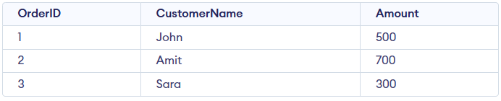Orders Table
Query:
SELECT SUM(Amount) AS TotalAmount
FROM Orders;
Output:
- SUM(Amount) calculates the total of all values present in the Amount column.
- The query returns one result named TotalAmount from the Orders table.
Syntax:
SELECT SUM(column_name)
FROM table_name;

Examples of SQL SUM() Function
In this section, we demonstrate the SUM() function using a Sales table (Product, Quantity, Price) to understand how it calculates totals and distinct sums; consider this Sales table for the below examples:
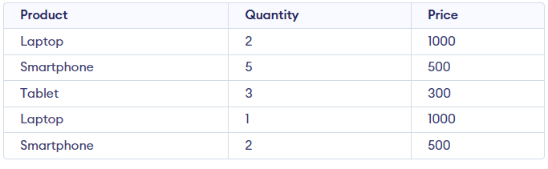Sales Table

Example 1: Using SUM() with One Column
In this example, SUM() calculates the total of a single numeric column.
Query:
SELECT SUM(Price) AS TotalPrice
FROM Sales;

Output:
- Adds all values in the Price column.
- Returns the result as TotalPrice.

Example 2: Using SUM() with an Expression
In this example, calculates total revenue by multiplying quantity and price.
Query:
SELECT SUM(Quantity * Price) AS TotalRevenue
FROM Sales;

Output:
- Multiplies Quantity × Price for each row.
- Returns the total revenue as TotalRevenue.

Example 3: Using SUM() with GROUP BY
In this example, SUM() is used along with GROUP BY clause. It calculates revenue separately for each product.

Query:
SELECT Product, SUM(Quantity * Price) AS TotalRevenue
FROM Sales
GROUP BY Product;

Output:
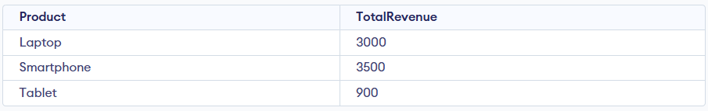
- Calculates revenue for each product.
- Groups rows by Product before summing.

Example 4: Using SUM() with DISTINCT
In this example, SUM() is used with the DISTINCT keyword to sum only unique price values.

Query:
SELECT SUM(DISTINCT Price) AS SumDistinctPrice
FROM Sales;

Output:
- Adds only unique Price values.
- Returns the result as SumDistinctPrice.

Example 5: Using SUM() with HAVING
The HAVING clause can be used with GROUP BY to filter groups based on the result of the SUM() function, allowing conditions on aggregated data.

Query:
SELECT Product, SUM(Quantity * Price) AS TotalRevenue
FROM Sales
GROUP BY Product
HAVING SUM(Quantity * Price) > 2000;

Output:
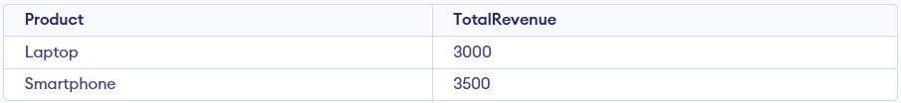
- Filters products after grouping.
- Shows only products with revenue greater than 2000.

SQL MAX() Function
Last Updated : 22 Nov, 2025

The SQL MAX() function helps quickly identify the highest value within any column, making it useful for summarizing and analyzing data trends. It is widely used in reports to find top values like peak sales, latest dates, or highest scores.
- Returns the maximum value from the specified column.
- Supports numeric, date, and text data types.
- Skips NULL values during calculation.
Example: First, we create a demo SQL database and table, on which we use the MAX() functions.
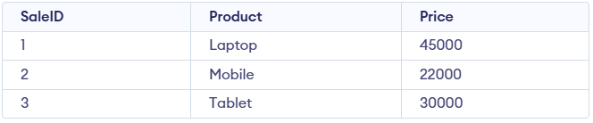SalesData Table
Query:
SELECT MAX(Price) AS HighestPrice
FROM SalesData;
Output:
- Finds the highest price from the Price column in the SalesData table.
- Returns a single value labeled as HighestPrice.
Syntax:
SELECT MAX(column_name)
FROM table_name;

Examples of SQL MAX() Function
Here, we demonstrate the usage of the MAX() function using a single sample table named Products. Consider this Products table for all the examples below:
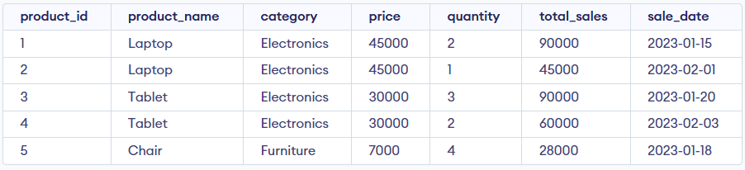Products Table

Example 1: Find the Maximum Price in a Table
In this example, we see how the MAX() function retrieves the highest total_sales value from the Products table while ignoring NULL values.
Query:
SELECT MAX(total_sales) AS [Highest Total Sales]
FROM Products;
Output:
- Returns the largest value from the total_sales column.
- Helps identify the highest sales amount in the entire table.

Example 2: Use MAX() with a Condition
In this example, we see how the MAX() function returns the highest price after filtering rows based on a specific condition.
Query:
SELECT MAX(price) AS [Highest Price in Electronics]
FROM Products
WHERE category = 'Electronics';
Output:
- Applies WHERE to include only products in the Electronics category.
- MAX() then returns the highest price within that filtered group.

Example 3: Find the Latest Sale Date
In this example, we use MAX() to get the most recent sale date from the table.
Query:
SELECT MAX(sale_date) AS [Latest Sale Date]
FROM Products;
Output:
- MAX(sale_date) returns the latest date stored in the column.
- Useful for identifying the most recent sale activity.

Example 4: Using MAX() with GROUP BY
In this example, we use MAX() with GROUP BY to find the highest sale amount for each product.
Query:
SELECT product_name, MAX(total_sales) AS [Top Sales Amount]
FROM Products
GROUP BY product_name;
Output:
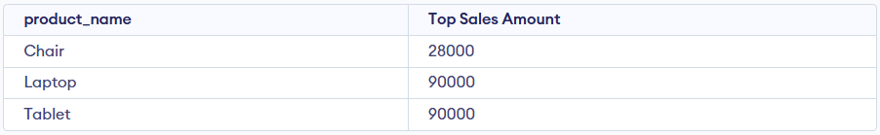
- Groups rows by product_name and applies MAX() to each group.
- Returns the top sales amount for every individual product.

Example 5: Using MAX() in Subqueries
In this example, we use MAX() inside a subquery to get the product with the highest total_sales.
Query:
SELECT *
FROM Products
WHERE total_sales = (SELECT MAX(total_sales) FROM Products);
Output:
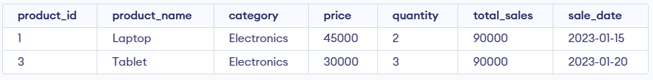
- The subquery returns the maximum total_sales value from Products.
- The main query fetches the full record that matches this highest value.

Example 6: Using MAX() with HAVING
In this example, we use MAX() with HAVING to filter product groups based on their highest total sales.
Query:
SELECT product_name, MAX(total_sales) AS HighestSale
FROM Products
GROUP BY product_name
HAVING MAX(total_sales) > 50000;
Output:
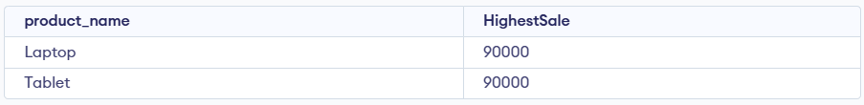
- GROUP BY creates groups for each product_name and calculates their MAX(total_sales).
- HAVING filters only those products whose highest sale exceeds 50,000.

AVG() Function in SQL
Last Updated : 22 Nov, 2025

The AVG() function in SQL calculates the average of a numeric column. It helps identify the central value of data by ignoring NULL entries. Overall, it is a quick way to summarize large datasets.
- Finds the average or mean using only non-null values.
- Useful for quick comparisons and basic data analysis.
Example: First, we create a demo SQL database and table, on which we use the AVG() functions.
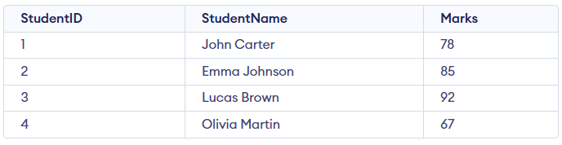Student Table
Query:
SELECT AVG(Marks) AS AverageMarks
FROM Student;
Output:
- AVG(Marks) computes the mean of all student marks.
- Returns one value showing the overall average score.
Syntax:
SELECT AVG(column_name)
FROM table_name;

Examples of SQL AVG() Function
Here, we demonstrate the usage of the AVG() function using a sample table named student_scores. Consider this student_scores table for all the examples below:
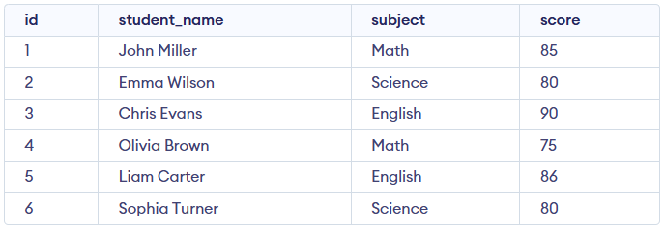student_scores Table

Example 1: Calculating Overall Average Score
In this example, we use AVG() to get the complete overall average of all scores.
Query:
SELECT AVG(score) AS overall_average_score
FROM student_scores;
Output:
- AVG() computes the average of all score values.
- Returns a single overall result.

Example 2: Calculating Average Score per Subject
In this example, we use AVG() with the GROUP BY clause to find the average score for each subject.
Query:
SELECT subject, AVG(score) AS average_score
FROM student_scores
GROUP BY subject;
Output:
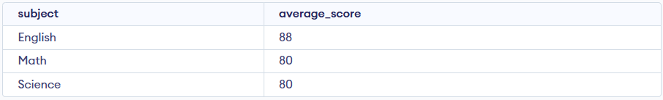
- GROUP BY groups rows by subject.
- AVG() calculates the average score for each group.

Example 3: Calculating Average Score for a Specific Subject
In this example, AVG() is used with a WHERE clause to find the average score only for Science.
Query:
SELECT AVG(score) AS average_science_score
FROM student_scores
WHERE subject = 'Science';
Output:
- WHERE filters rows to include only Science.
- AVG() calculates the average from the filtered data.

Example 4: Showing Only Subjects with Average Score Above 85
In this example, we use AVG() with HAVING to display only those subjects whose average score exceeds 85.
Query:
SELECT subject, AVG(score) AS average_score
FROM student_scores
GROUP BY subject
HAVING AVG(score) > 85;
Output:
- HAVING filters groups based on aggregate values.
- Only subjects with an average score > 85 are shown.

Considerations
While the AVG() function is a powerful tool for data analysis, there are some considerations to keep in mind:
- NULL Handling: AVG() ignores NULL values, which may impact results if many entries are missing.
- Numeric Columns Only: The function works only on numeric data—using it on non-numeric columns causes errors.
- Precision: AVG() can return long decimals; round the result when cleaner output is needed.

